There are 3 types of statements.

1) Statement

2) Prepared Statement.

3)Callable Statement.

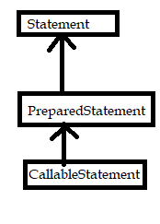

Statement is interface.

PreparedStatement is child interface of Statement.

CallableStatement is child interface of PreparedStatement.

1. **Statement:-** It is interface. Its implementation is responsibility of DB vendor. It provides methods to execute queries with database.

Statement var-name = con.createStatement();

createStatement () method returns the object of implementation class of Statement interface. This object is pointed by Statement type variable.

The name of implementation class of Statement()interface is changed from driver s/w to driver s/w. Remembering Implementation class name and Declaring implementation class type variable is difficult to programmer. Therefore It is better to refer the object with Statement type variable.

Methods:-

1. executeQuery:-

public ResultSet executeQuery(“select Query”) throws SQLException.

This method is used for executing the select operation. It returns the ResultSet.

1. executeUpdate:-

Syntax: public int executeUpdate(“non-select query”) throws SQLException.

This method is used for executing the non-select operations(insertion,deletion,updataion) .It returns integer value. This number represents no.of rows affected in table.

1. executeLargeUpdate:-

Syntax:- public long executeLargeUpdate(“non-select query”) throws SQLException.

If non-select query is manipulating the long data-type range no.of records.

d)Execute:-

Public Boolean execute(“SQLquery”)throws SQLException.

If we don’t know type of query in advance and it is available dynamically then we should use execute() method .

It returns either true or false. True represents executed query is select query. False means executed query is non-select query.

EX:- Boolean b=statementobject.execute(“query”);

If (b==true)

{

Resulstset r=statementobject.getResultset();

}

Else

{

Int a=statementobject.getUpdateCount();

}

If we use simple statement object to execute the same SQL query multiple times with same inputs or different inputs then,

1. It sends the same sql query to db s/w multiple times.
2. The Db s/w compile the same sql query multiple times.
3. The DB s/w executes the same sql query multiple times.
4. The output of query will be collected and will be sent to java application multiple times.

Note:- In above steps, performing steps(a and b) on same sql query is unnecessary.Performing steps(c&d) on same sql query is necessary.

Usecases for executing same sql query for multiple times.

----------------------------------------------------------------------

1. Getting live cricket match score continuously.
2. Bus/train/airbus reservation.
3. Stock market share value gathering
4. Getting same train location continuously.

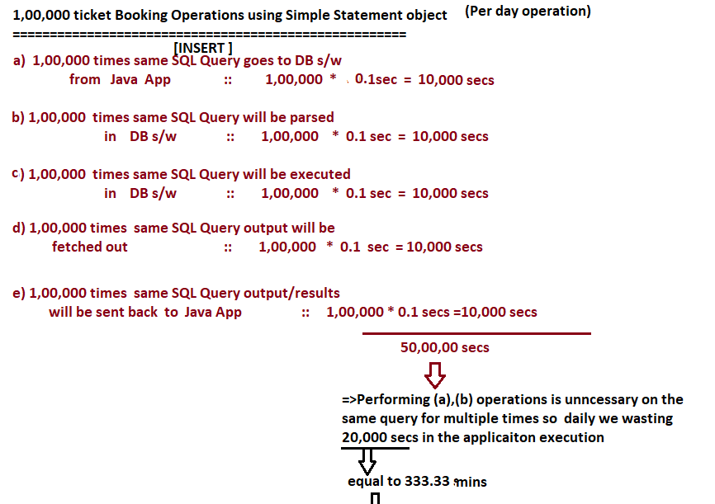



Limitations:-

1. It is not suitable for executing sql query with same inputs and different inputs for multipletimes.
2. SQL query does not allow the Params(?).
3. SQL Injection attack may araise.
4. Not Suitable for inserting “Date” values in table .
5. Not Suitable for inserting BLOBS and LOBS(Images, audio,videos..etc).